**Ministerul Educaţiei și Cercetării al Republicii Moldova**

**Colegiul Universitatii Tehnice a Moldovei**

RAPORT

Lucrarea de laborator

Asistenta pentru OOP

A efectuat: Ciuprov Anastasia PAPP-221

A verificat: Cătălin Coșeru

Chişinău – 2024

Tema lucrarii: Bazele OOP

A simple laboratory work focused on the basics of Object-Oriented Programming (OOP). In this lab, students

will create a basic program to manage a library of books using Python. This lab covers the fundamental

concepts of classes, objects, and basic inheritance.

Lab Title: Simple Library Management System

Objective: To create a simple Library Management System using Object-Oriented Programming concepts.

Sarcina lucrării:

1. Implement two classes: Book and Library.

2. The Book class should have attributes like title, author, and ISBN.

3. The Library class should have a list to store books and methods to add a book, remove a book, and

display all books in the library.

4. The code should be uploaded to your github account, if not then make sure you’ll create one.

5. Your repository should be public.

6. You can use gitUI, fork or other programs instead of git command line.

Corpul programului:

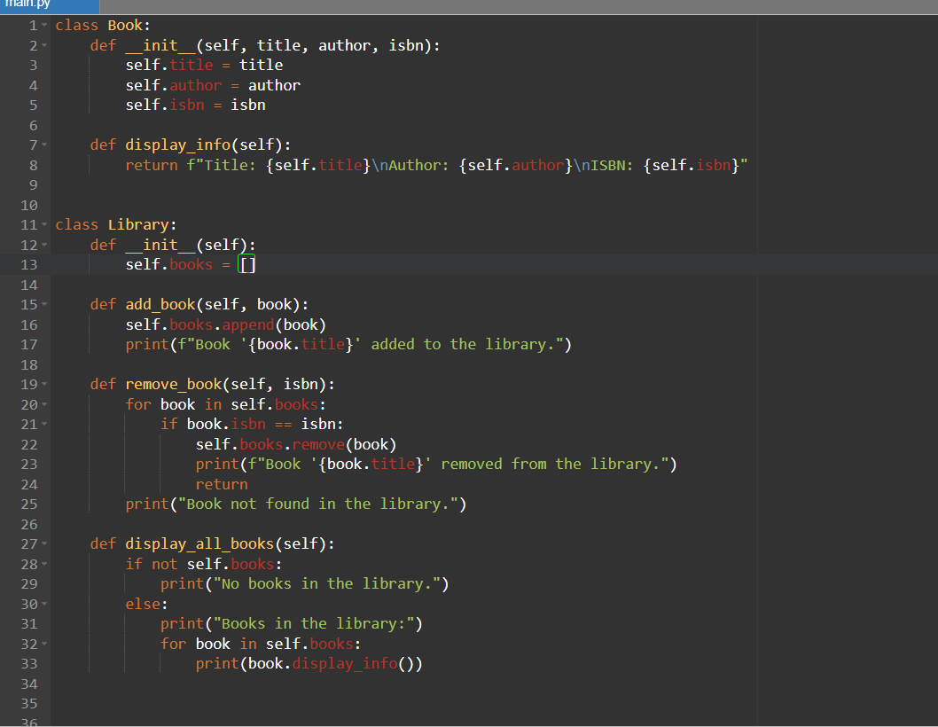

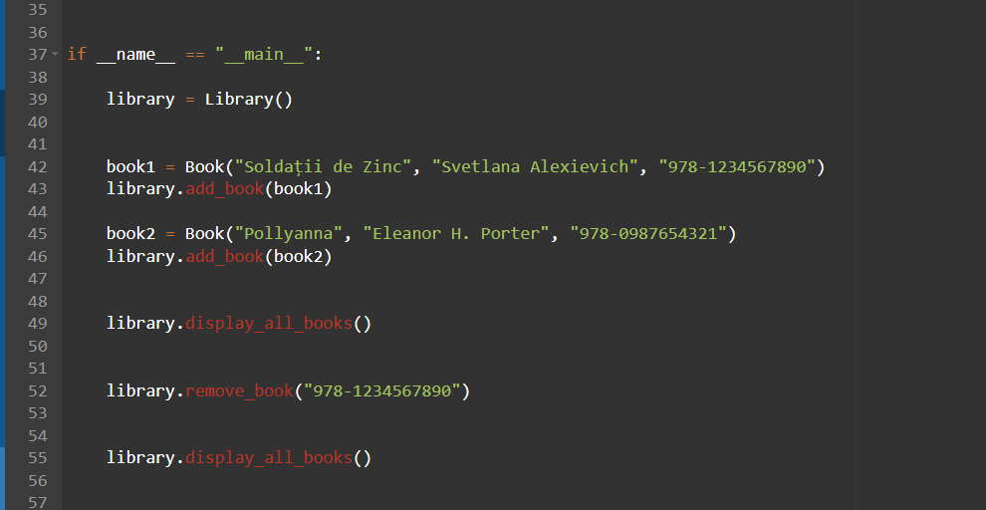

Outputul:

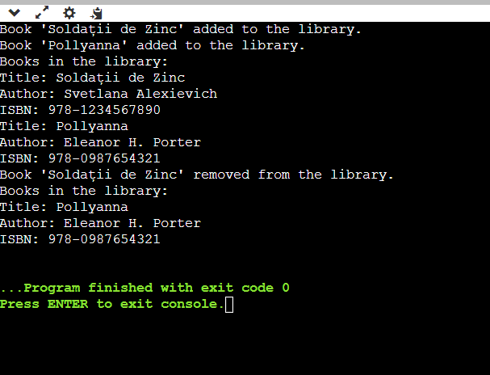

Concluzie: In cadrul laboratorului numarul 1 am reusit sa implementam 2 clase, si sa efectuam cateva operatiuni in campul acetor clase, respectiv acoperind principiile de baza a OOP-ului.